***Reaching an MVP State***

For a product or demo to reach a MVP state means making it to be a ‘minimum viable product’. This version of our product will include all the features necessary to release the product into the market by solving the core problem for a set of users. This plan will allow us to provide immediate value, while minimizing development costs. To design a plan to bring the demo to MVP state, we need to follow and understand the valuable steps of : Understanding the Business Needs, Finding the Opportunities, and Deciding what features to build (Prioritization Matrix).

*Understanding the Business Needs*

A product is fit to acquire a place in the market once it has a good UX/UI with adequate feature set and value proposition and also a good foundation of knowledge on the target customers.

Knowing the long-term goal gives a good start to the plan. Our long-term plan includes a well functioning platform with educational services, diverse products, activities and services for users to enjoy and also creating a good space for knowledge on the upcoming advanced technologies. Understanding user-personas is important. This can be done by recognizing the needs of the customers. The expectations of users include being provided with a good educational service and an easy to navigate platform that displays adequate information on the site about the various features and activities the site has to offer. Some motivations for attracting a good customer base is the loyalty program page, various activities and interesting courses and modules. There will also be a few pain points that customers might face. For instance, no knowledge about the advanced tech and hence probably facing trouble in understanding either steps or modules easily. The success criteria can be measures by an increased number of users logged in, growing blockchain network, escalating ties-up with universities and other partners who are ready to offer products and services.

*Find the opportunities*

An opportunity can be found by listing down the users, their jobs and how we want this process to end.

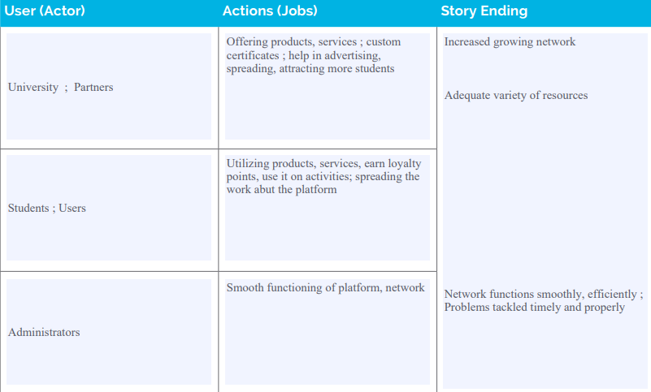

Similarly, understanding pains and what actions to take for overcoming those and entrapping a gain is important.

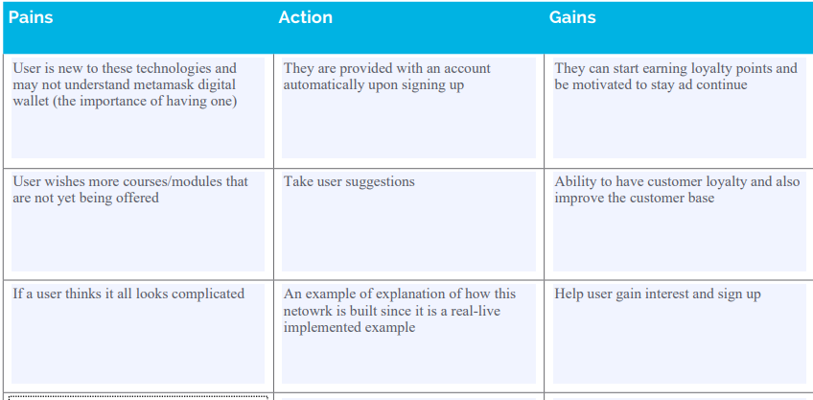

These tables help us realize opportunities like how we can gain audience trust and loyalty, grow our network and also improve the platform.

*Prioritization Matrix*

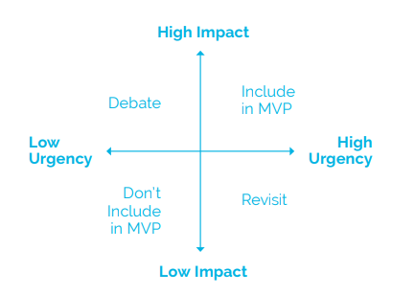

This prioritization matrix finally helps in building an efficient MVP.

For instance, finding Universities and partners that are ready to offer products and services are impactful but not urgent and hence they are debatable to be included in MVP. On the other hand, having a few modules from either InnovFin team is impactful and urgent and hence will be needed in MVP. Automated issuing and assigning of certification again debatable. Now, a chat feature for helping users guide through the website may have low impact and is definitely not an urgent requirement, hence it can be avoided from MVP.

*Few more points to keep in mind :*

The main page of Innov-Edu platform should be implemented efficiently. An overall good design would include consistency of colors and design, while having easy navigation. A menu bar with all options self-descriptive. Information blocks about the program and platform and few extra articles for explanation about the topic.

Certification Program with a good interface and explanatory blanks so user knows what to enter and where.

The platform should allow a user to sign up with or without metamask digital wallet. They can access the courses and modules on the platform and earn points which they can redeem for various methods that they can choose.